**Contents for The Newsletter 2021-22**

**Department Vision Mission, etc**

same as in last newsletter

**HOD's Message**

Sent separately

**Editorial**

Sent separately

**Students' Academic Achievements (2020-21)**

B.E. (EXTC)

| **Sr. No.** | **Name of Student** | **GPA** |
| --- | --- | --- |
| 1 | Mendes Cromwell Francisco Socorrinha | 10 |
| 2 | Kulkarni Shreyas Deepak Deepali | 10 |
| 3 | Chaubey Saurabh Dinesh Santosh | 9.9 |

TE (EXTC)

| **Sr. No.** | **Name of Student** | **GPA** |
| --- | --- | --- |
| 1 | Katariyar Shubhangi Anup Kumar Manisha | 9.83 |
| 2 | Prabhu Vidit Rajesh Sheetal | 9.64 |
| 3 | Ajitha Rajkumar Sasikala | 9.63 |

**Journal Publications**

1. Roni Thomas, Amanda Joseph, Redalia D’Souza, Aishwarya Kadam, Namita Agarwal published a paper titled “Geo Mapping and Analysis of Alumni Data (with Full Stack Web Development)” in International Journal of Emerging Technologies and Innovative Research,Volume 8, Issue 6, 2021.
2. Brayan Dialle, Kevin D'souza, Ryan Fernandes, Aparna Telgote published a paper titled “Televoting System for Rural Development using VSAT” in the International Journal of Emerging Technologies and Innovative Research, Volume 8, Issue 5, 2021-05-14.
3. Vanitha Soman, Sudhakar S Mande, K Vijayakumar, “[A 4-Bit 4GS/s Differential Current Steering DAC for 16-bit PAM Transmitter in 45-nm CMOS Technology](https://link.springer.com/article/10.1007/s13204-021-02101-1),” International Journal of Applied Nanoscience https://link.springer.com/article/10.1007/s13204-021-02101-1.

**Conference Papers**

1. Abhishek Tripathi, Shafaque Shaikh, Elton Noronha, Sagar Kote, Pratibha Dumane, Satishkumar Chavan presented a paper titled “Fuzzy Based Sustainable Development Assessment for South Asian Countries” in the Conference on Technologies for Future Cities (CTFC 2021) organised by Pillai College of Engineering, New Panvel, on 8-9 October 2021.
2. R. Carvalho, E. Gomes, P. Rao, L. Pereira, A. Kotrashetti and S. Gupte, "A Comparison of Compensation Networks for Wireless Charger for Electric Vehicles," 2021 IEEE Bombay Section Signature Conference (IBSSC), 2021, pp. 1-6, doi: 10.1109/IBSSC53889.2021.9673330.
3. K. Barnes, S. Kulkarni, A. Sthalekar, J. S. Isaac and A. Kotrashetti, "LoraWAN Enabled Solar Photovoltaic Energy Monitoring System," 2021 IEEE Bombay Section Signature Conference (IBSSC), 2021, pp. 1-6, doi: 10.1109/IBSSC53889.2021.9673295.
4. S. Mannaruparampil, A. Serrao, S. Singh, F. Carvalho and A. Kotrashetti, "Design and Development of Mobile Handset Antenna for Optimum SAR for Mobile Communication System," 2021 IEEE Pune Section International Conference (PuneCon), 2021, pp. 1-6, doi:10.1109/PuneCon52575.2021.9686538.
5. Ahmed Ansari, Khan Rizwan, Mohammed Fawzaan Roghay, Shaikh Faisal, Sudhakar Mande, “A Novel Encoder Architecture for 8-bit Flash ADC”, 2021 International Conference on Smart Generation Computing, Communication and Networking (SMART GENCON[)](https://ieeexplore.ieee.org/xpl/conhome/9645753/proceeding), DOI:[10.1109/SMARTGENCON51891.2021.9645882](https://doi.org/10.1109/SMARTGENCON51891.2021.9645882)
6. [Siddhi Warang](https://ieeexplore.ieee.org/author/37089199002), [Mark Gracious](https://ieeexplore.ieee.org/author/37089203633), [Siddhi More](https://ieeexplore.ieee.org/author/37089204927), [Mangeshi Patil](https://ieeexplore.ieee.org/author/37089202306), [Sudhakar S. Mande](https://ieeexplore.ieee.org/author/37658692300), “Design of Ultra Low Noise High Precision Bandgap Voltage Reference”, 2021 International Conference on Smart Generation Computing, Communication and Networking (SMART GENCON[)](https://ieeexplore.ieee.org/xpl/conhome/9645753/proceeding),

DOI: [10.1109/SMARTGENCON51891.2021.9645889](https://doi.org/10.1109/SMARTGENCON51891.2021.9645889)

**Faculty Recognition**

1. Dr. Ashwini Kotrashetti continued to be a reviewer for IETE Journal of Research.
2. Ms. Gejo George was appointed as a Reviewer for the 3rd IEEE Bombay Section Signature Conference (IBSSC-2021), an international conference organized by IEEE Bombay Section and ABV-IIITM Gwalior, India, November 18-20, 2021.
3. Mrs. Pratibha Dumane was appointed as the Primary Evaluator for TOYCATHON-2021, a Hackathon to crowdsource innovative ideas for Toys and Games based on Bharatiya history, civilization, ethos and culture organized by the Innovation Cell, Ministry of Education with support of AICTE, Ministry of Women and Child Development, Ministry of Textiles, Ministry of MSME, Ministry of Commerce and Industry, Ministry of Information and Broadcasting.
4. Mrs. Pratibha Dumane was appointed as a Reviewer for the 3rd International Conference on Information Management & Machine Intelligence (ICIMMI 2021) organized by Poornima Institute of Engineering & Technology, Jaipur, Rajasthan, India on December 23-24, 2021, with publication partner Springer Nature.
5. Mrs. Pratibha Dumane was appointed as a Judge for the Technical Writing Competition by the IETE Mumbai Centre as a part of the IETE Student’s Day Celebrations during Oscillations 2K22.
6. Dr. Ashwini Kotrashetti served as Organizing Committee Member & Track Chair for the “Humanitarian and Social Impacts of Technologies” track for TENSYMP 2022, IEEE Region 10 Symposium organized from 01- 03 July 2022 at IIT Bombay.
7. Dr. Ashwini Kotrashetti was invited as External Expert to interview candidates for the post of Research Scientist (Electronics & RF Engineering) on 19-20 April 2022 at SAMEER, Mumbai.

**Faculty Engagements with the University of Mumbai**

1. Dr. Sudhakar Mande worked as Chairman of Syllabus Drafting Committee of the course on “ECCDLO7011 Efficient Architectures for DSP Algorithms” of University of Mumbai R-2019 C -Scheme.
2. Dr. Sudhakar Mande worked as Chairman of Syllabus Drafting committee of the course on “ECCDLO8011 System of Chip Design” of University of Mumbai R-2019 C -Scheme.
3. Ms. Pratibha Dumane was appointed as a Member of the University of Mumbai Syllabus Drafting Committee “ECC 604 Artificial Neural Networks & Fuzzy Logic”, R-2019 C - Scheme. She also was an organizing team member for the Online Faculty Orientation Programme organized by Vivekanand Education Society’s Institute of Technology, Mumbai on behalf of University of Mumbai on 15 January 2022 for the course.
4. Ms. Namita Agarwal was appointed as a Member of the University of Mumbai Syllabus Drafting Committee “ECC 602 Computer Communication Networks”, R-2019 C - Scheme. She was also an organizing team for the Online Faculty Orientation Programme on behalf of University of Mumbai on January 14, 2022.
5. Mrs. Poonam Chakraborty was appointed as a member of the Syllabus Drafting Committee for “ECCDLOC 8023 Network & Management in Telecommunication” for the R2019 C scheme.
6. Ms. Gejo George was appointed as a member of the Syllabus Drafting Committee for “ECCDLO8022 - Satellite and Nano Satellite Communication” for the R2019 C scheme.

**Certifications by Faculty Members**

* Dr. Sudhakar Mande completed the NPTEL courses on
  + “Introduction to the Internet of Things” in December 2021.
  + “Hardware Modelling Using Verilog” with an Elite certificate in December 2021.
  + “C-Based VLSI Design” with an Elite certificate in December 2021.
* Mrs. Pratibha Dumane completed Certificate Courses on
  + “Advanced Neural Networks in R - A Practical Approach” by Udemy.
  + “Natural Language Processing Real-World Projects in Python” by Udemy.

**Invited Talks by Faculty Members**

1. Ms. Freda Carvalho & Mr. Tayyabali Sayyed, Faculty-IT Dept. conducted a hands-on training session on “Moodle” for Faculty Members of Holy Family Institute of Nursing Education, Kurla (W), Mumbai, on 05 & 07 July 2021.
2. Dr. Sudhakar Mande delivered a webinar on “Recent trends and Career Opportunities in Electronics & Telecommunication Engineering” at St. John Institute of Technology, Palghar, Thane in August 2021.. URL: https://drive.google.com/drive/shared-with-me
3. Dr. Sudhakar Mande delivered a webinar on “What is Final Year Engineering Project (FYEP)” to Final Year Engineering students at DBIT in August 2021. https://drive.google.com/drive/folders/1bZ01wVyYkKNLt-eanIu_Bbtj_eSIKu-E
4. Dr. Ashwini Kotrashetti was invited to deliver a talk on “Financial Planning, Sponsorships and Collaboration with IEEE MTT-S” at the 2021 R10-POCO Virtual Workshop on 21 August 2021.
5. Mrs. Poonam Chakraborty delivered a talk on “Passive Optical Networks” on 02 September 2021 for the final year EXTC students of Xavier Institute of Engineering, Mumbai.
6. Dr. Sudhakar Mande delivered a talk on “Overview of Memory and Storage Devices” at Fr. C. Rodrigues Institute of Technology, Vashi, Navi Mumbai in September 2021.
7. Mrs. Pratibha Dumane was invited to deliver a talk on “Becoming Future-Fit” during the Induction Programme for the first year students of Government Polytechnic, Pen, District Raigad, Maharashtra on 12 October 2021.
8. Dr. Sudhakar Mande delivered a webinar for parents and students of standard XII on “Electronics & Telecommunication Engineering: Scope & Opportunities” on 30 October 2021. URL: https://www.youtube.com/watch?v=fQHKXp8suWk
9. Dr. Ashwini Kotrashetti delivered a talk on “Radar Sensors” at the 27th National Conference on Sensors in Automation organized on 19-20 November 2021.
10. Ms. Freda Carvalho and Mr. Tayyabali Sayyed, Faculty-IT Dept., conducted a hands-on training on “Moodle” for the teaching staff of Pillai College of Engineering, New Panvel on 26 January, 2022.
11. Dr. Sudhakar Mande was invited to deliver a talk on “Bloom's Taxonomy: Tool for Enhancing Quality of Engineering Education” on 01 April 2022 in the IQAC Talks Series organized by Oriental Institute of Sciences and Technology, Jabalpur.
12. Dr. Sudhakar Mande delivered a talk on “Bloom’s Taxonomy: Tool for Writing Quality Course Outcomes and to Establish Efficient CO-PO-PSO Correlation Matrix” during Faculty Development Programme at DBIT on 24 May 2022.
13. Mrs. Pratibha Dumane conducted a session on “Becoming Future Fit” under the Value Added Course organized for the first year students of DBIT on 21 & 28 April 2022.
14. Mrs. Gejo George conducted a session on “Effective Team-Work” under the Value Added Course organized for the First Year Students of DBIT on 13 & 19 May 2022.

**Student Achievements**

1. Rakshita Khantwal, Sarika Galphade, Adarsh Rao secured the Second, Third and Consolation Prize in the Technical Writing Competition conducted by IETE-DBIT-ISF on behalf of IETE Mumbai Centre as part of the IETE Student’s Day Celebration on 01 February 2022.
2. Pratham Milind Amare, Pratham Pravin Koturwar, Bhagyesh Shubhas Manjrekar secured the First Prize in Technical Treasure Hunt Competition organized under Oscillations 2022.
3. Rohit Radhashayam Gupta, Kshitij Bare, Nitish Chavan secured the Second Prize in Technical Treasure Hunt Competition organized under Oscillations 2022.
4. Satyam Shukla, Jay Dulange, Leroy Rodrigues secured the Third Prize in Technical Treasure Hunt Competition organized under Oscillations 2022.

**EXTC Students In Student Council**

| **Sr. No.** | **Designation** | **Name of Student** | **Class** |
| --- | --- | --- | --- |
| 1 | Cultural Secretary | Mr. Abdul Rehman Khan | BE EXTC |
| 2 | Sports Secretary | Mr. Sahil Yelgonda | BE EXTC |

**Guest Lectures**

| **Sr. No.** | **Topic** | **Resource Person** | **Organisation** | **Date** |
| --- | --- | --- | --- | --- |
| 1 | SONET/SDH | Mrs. Shaileja Udtewar | Xavier Institute of Engineering, Mumbai | 9 September 2021 |
| 2 | Microwave Heating using Magnetrons | Mr. Rajesh Rangari | Scientist E, HOD of EMI/EMC Division, SAMEER, Mumbai Division | 16 October 2021 |
| 3 | VANET | Dr. Amiya Kumar Tripathy | Professor, Computer, Department, Don Bosco Institute of Technology | 28 March 2022 |
| 4 | Considering EMC at Design Stages | Mr. Rajesh Rangari | Scientist E, HOD of EMI/EMC Division, SAMEER, Mumbai Division | 09 April 2022 |

**Alumni Interactions**

| **Sr. No.** | **Topic** | **Date** | **Alumnus Speaker** |
| --- | --- | --- | --- |
| 1 | Use of CNN for Classification with Google Colab | July 03, 2021 | Mr. Abhiram Pillai  (Batch 2021) |
| 2 | The Data Journey from Source to Visualisation | 21 October 2021 | Ms. Tanuja Mehra, (Batch 2019), Incubyte Datatech |
| 3 | Cyber Security | 14 March 2022 | Ms. Sanjana Ingale (Batch 2017), Consultant - Cyber & Strategic Risk, Deloitte India (Offices of the US) |

**Outreach Activities**

* Ms. Freda Carvalho & Mr. Jithin Isaac conducted STEM courses on “merApp: Mobile App Development” and “NatureSense: Basics of Electronics & Integration with Sensors” for low income school children under “Engineering Futures - CrEAST” program, a funded project of L&T CSR Department from 1 July 2021 to 31 Dec 2021. The program was coordinated by Dr. Ashwini Kotrashetti.
* Ms. Gejo George alongwith the IEEE student volunteers conducted a hands-on training workshop on ‘Techworld - a STEM Workshop’ for the students of class 8 and 9 at Mumbai Utkal English School and Shishu Vikas Mandir on 25 February 2022 and 08 March 2022 respectively.

**Student Placements**

| **Sr. NO.** | **Name** | **Company** | **Additional offer letter** |
| --- | --- | --- | --- |
| 1 | Velton D’Souza | LTI |  |
| 2 | Rohan Ghai | LTI |  |
| 3 | Vaibhav Parate | Evosys Global | Link Group |
| 4 | Manas Bhandarkar | Evosys Global | Link Group |
| 5 | Sadanand Chauhan | Evosys Global | Samsung |
| 6 | Saurabh Shete | Evosys Global | Capgemini |
| 7 | Chaitanya Muzumdar | Evosys Global | Acumen Security |
| 8 | Varun Gokran | Evosys Global |  |
| 9 | Ritik Kumar | Link Group | L&T Heavy Engineering |
| 10 | Aman Khan | Jio |  |
| 11 | Arka Dey | Jio | LTFS |
| 12 | Pramod Mohanty | Jio |  |
| 13 | Shantanu Patil | Jio |  |
| 14 | Ajitha Rajkumar | Jio |  |
| 15 | Krupakar Arroju | Jio |  |
| 16 | Abhijit More | Jio | TCS Ninja |
| 17 | Shardul Powale | Jio | TCS Ninja |
| 18 | James Kundukulangara | Jio | TCS Ninja |
| 19 | Balkrishna Sawant | Hexaware | TCS Ninja |
| 20 | Bhavesh Barde | Capgemini |  |
| 21 | Shubhangi Katariyar | Capgemini | TCS Digital |
| 22 | Vedant Devrukhkar | Growisto |  |
| 23 | Callistus Pani George | TCS Ninja |  |
| 24 | Srujan Mhase | TCS Ninja |  |
| 25 | Vidit Prabhu | TCS Ninja |  |
| 26 | Sakshi Gadekar | TCS Ninja |  |
| 27 | Abhinav Shukla | TCS Ninja | L&T Heavy Engineering |
| 28 | Rahul Singh | Square Yards | CodeYoung,QSPIDER |
| 29 | Sahil Yelgonda | Square Yards | Q Spider, Euronet |
| 30 | Nikhit Rapelli | Q Spider | Linedata |
| 31 | Amit Suryabhan Rajbhar | Q Spider | NetCore |
| 32 | Saadiya Dafedar | RSM | Hansa Equity |
| 33 | Rudra Hemant Pangerkar | LTFS |  |
| 34 | Ankita Kadam | NetCore |  |
| 35 | Solomon Stephen | NetCore |  |
| 36 | Kyle Dsouza | NetCore |  |
| 37 | Rameshwar Chavan | Highbar Technocrat |  |
| 38 | Vivek Bangera | Wipro | LTI |
| 39 | Aman Singh | Wipro |  |
| 40 | Ashutosh Rane | Wipro | Piramal |
| 41 | Joshua Chettiar | Research Wire |  |
| 42 | Merlin Tomy | Highbar Technocrat | Qspider |
| 43 | Akash Sagare | NucSoft | ReBIT (subsidiary of RBI) |
| 44 | Preeti Rajpure | Palle Technologies |  |
| 45 | Dhanashree Chilap | Q Spider |  |
| 46 | Perez Dasan | Q Spider |  |
| 47 | Abdulrehman Jiyaullah Khan | Clevernist,ReBIT | NetCore |
| 48 | Neil Furtado | Piramal |  |
| 49 | Hitesh Badgujar | L&T Heavy Engineering |  |
| 50 | Adarsh Pandey | Acumen Security |  |
| 51 | Nilesh Pal | ReBIT (subsidiary of RBI) |  |

**Internships In Industry**

| **Sr. No.** | **Name of Student** | **Organisation** |
| --- | --- | --- |
| 1 | Abhijit More | The Sparks Foundation: GRIP (Web Development & Designing) |
| 2 | Vaibhav Parate | DevArena Solutions |
| 3 | Srujan Mhase | Rajasthan Studio |
| 4 | James Robin | The Sparks Foundation: GRIP |
| 5 | Merlin Tomy | United HVAC Pvt Limited, The Sparks Foundation: GRIP |
| 6 | Ajitha Rajkumar | IEEE-DBIT, Allonsy Venture |
| 7 | Ankita Kadam | TCR Innovation |
| 8 | Khan Abdul Rehman | Campus Ambassador - IIM Bangalore's Vista  Curriculum Writer - Team Everest NGO  Mindely - Business Development Associate |
| 9 | Atul Kumar | Nature Sense Engineering Future – CrEAST-DBIT & St. JTS in association with L&T |
| 10 | Aman Khan | IIT BHU |
| 11 | Velton D’souza | Fields Data |
| 12 | Shubhangi Katariyar | Labdox Pvt. Ltd. |
| 13 | Hitesh Badgujar | IIT BHU |
| 14 | Solomon Stephen | IIT BHU |
| 15 | Magdeline James | Alpha Impex Pvt. Ltd. |
| 16 | Ankit Naphade | Shavison Electronics Pvt. Ltd. |
| 17 | Vineeth Vikramsingh | Lead and Sales |
| 18 | Preeti Rajpure | TCR Innovation |
| 19 | Shardul Powale | The Sparks Foundation: GRIP |
| 20 | Sakshi Gadekar | Mahindra Susten (MSCOE) |
| 21 | Ashutosh Rane | Wellness Forever Medicare Pvt. Ltd. |
| 22 | Sadanand Chauhan | IIT BHU |
| 23 | Shantanu Patil | The Sparks Foundation: GRIP |
| 24 | Amit Rajbhar | Rishabh Electronics |
| 25 | Rutvik Kadam | Shavison Electronics Pvt. Ltd. |
| 26 | Nilesh Pal | Ashish Telecom and Solutions |
| 27 | Rahul Singh | Larsen & Toubro |
| 28 | Ashwini Sapkale | Edgate technology Pvt. Ltd. |
| 29 | Krupakar Arroju | Tri Vision Engineering |

**IEEE-DBIT Student Branch**

Committee Members

**IEEE Student Branch Activities**

**Workshops**

| **Sr. No.** | **Topic** | **Date** | **Speaker** |
| --- | --- | --- | --- |
| 1 | TinkerCad Workshop | 3 - 4 July 2021 | Mr. Velton D’Souza  Ms. Ajitha Rajkumar |
| 2 | Introduction to Convolutional Neural Networks (CNN) and its Use for Image Classification | 28 September 2021 | Dr. Bhakti Vilas Baheti  (Postdoctoral Researcher, Department of Radiology, Perelman School of Medicine, Pennsylvania , USA) |

**Webinars**

| **Sr. No.** | **Topic** | **Date** | **Speaker** |
| --- | --- | --- | --- |
| 1 | 2 Half-Day Online Symposium on “5G: A Catalyst To Digital Revolution” | 8-9 October 2021 | Mr. Hermes Joel, Founder & Director, Taranga Systems Ltd., Leicester, UK  Dr. Jaume Anguera, Founder and CTO, Ignion, Associate Professor, Universitat Ramon Llull, Barcelona, Spain  Dr. SaiDhiraj, Principal Research Engineer, WiSig Networks. Adjunct Assistant Professor, IIT Hyderabad  Dr. Jasmin Grosinger, Associate Professor & DL Institute of Microwave & Photonic Engineering, Univ. of Technology, Graz, Austria |
| 2 | Roboton - Robotics Symposium | 15- 17 October 2021 | Mr. Saptarshi Mukherjee, Mr. Lentin Joseph, Mr. Salmon Joy |
| 3 | What is My Measurement Equipment Actually Doing? (MTTS) | 11 March 2022 | Dr. Jon Martens, Engineering Fellow, Anritsu, San Jose, California, USA |
| 4 | Considering EMC at Design Stages (MTTS) | 09 April 2022 | Mr. Rajesh Rangari, Scientist - E, SAMEER, Mumbai |

**Interactions with Alumni**

| **Sr. No.** | **Topic** | **Date** | **Speaker** |
| --- | --- | --- | --- |
| 1 | Product Development and Engineering Design as a Career | 12 April 2021 | Mr. Gaurav Pednekar, (Alumnus - 2015 Batch), Design Engineer Consultant, Capgemini India Tech. Services |
| 2 | An Insight into Life after DBIT | 13 April 2021 | Ms. Lakshmi Prasad (Alumnus - 2017 Batch)  Scientist, Liquid Propulsion Systems Centre |
| 3 | Insights into Life @ DBIT | 05 June 2021 | Ms. Minita Joshee (Alumnus - 2021 Batch), Assistant System Engineer - Trainee at Tata Consultancy Services |

**Talks**

| **Sr. No.** | **Topic** | **Date** | **Speaker** |
| --- | --- | --- | --- |
| 1 | Document Version Control using Git & GitHub | 03 September 2021 | Ms. Ajitha Rajkumar & Mr. Pramod |
| 2 | IEEE Membership Awareness | 24 September 2021 | Dr. Ashwini Kotrashetti & Mr. Shreyas Kulkarni |

**Other Activities of IEEE-DBIT Student Branch**

* Everything about IEEE | What it is and it's benefits on 21 February 2021
* IEEE Student Memberships Benefits on 24 February 2021 by Ms. Ajitha Rajkumar
* A Walk Down Memory Lane of Core Team 2020 on 25 February 2021
* IEEE Grants & Funding on 05 March 2021
* Microwave Mondays on 22 March 2021, 5, 12, 19 April 2021, 03 May 2021, 22 & 28 June 2021
* Mystery Word Puzzle on 08 April 2021 by Ms. Ajitha Rajkumar
* Content Writing Competition on 08 April 2021
* WIE Wednesday on 23 June 2021 & 30 June 2021

**IETE-DBIT-ISF Student Chapter**

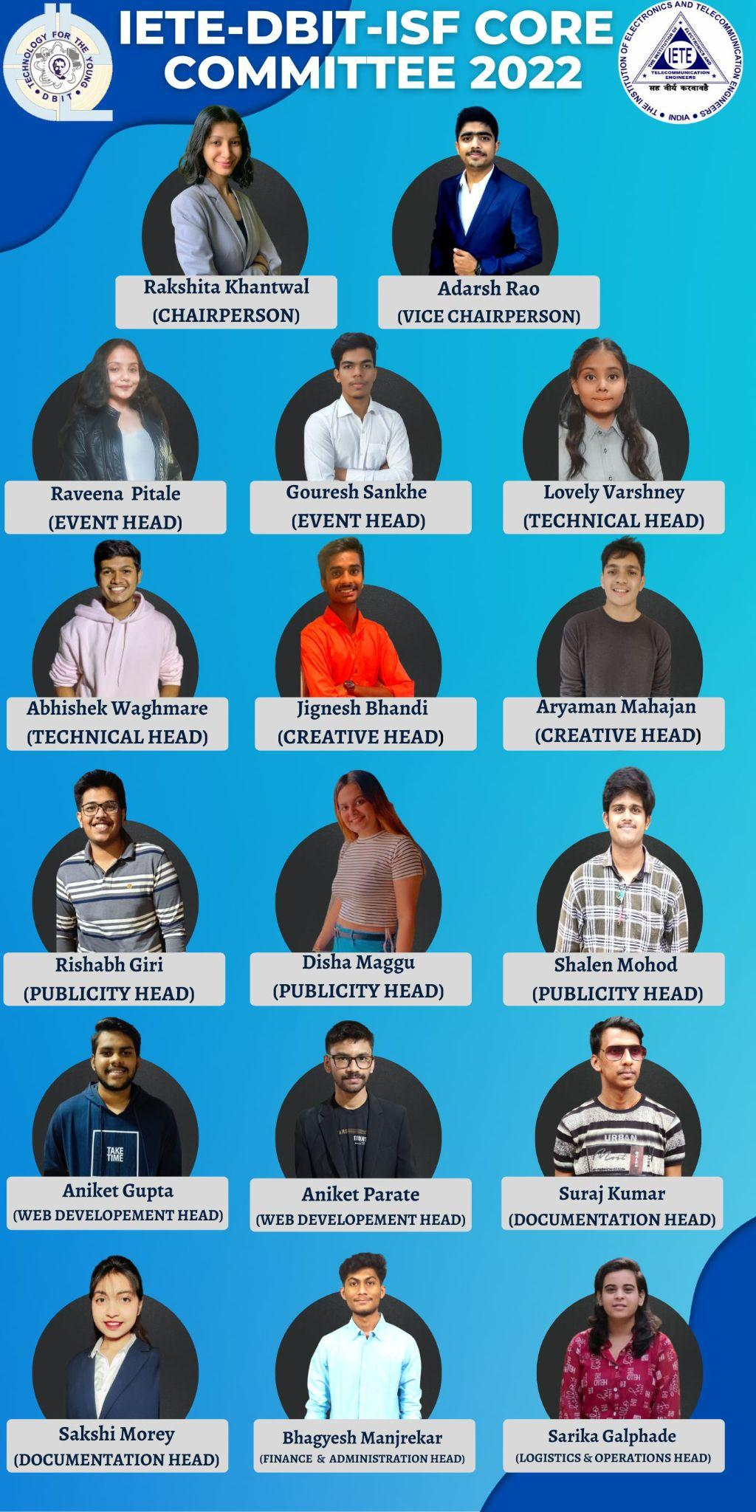

**IETE-DBIT ISF Activities**

**Quizzes**

* Quiz on Data Analytics on 23 November 2021.
* Quiz on Predict the Output on 11 December 2021.
* Quizathon on 31 January 2022.

**Workshops**

* Workshop on WordPress (Collab) on 20 September 2021.
* Workshop on Proteus on 09 October 2021 .

**Competitions**

* Poster Making Competition was organized on 27 February 2021 under Oscillations 2022.
* Technical Writing Competition on 01 February 2022 as a part of the IETE Students’ Day Celebrations.
* Technical Treasure Hunt on 11 April 2022.

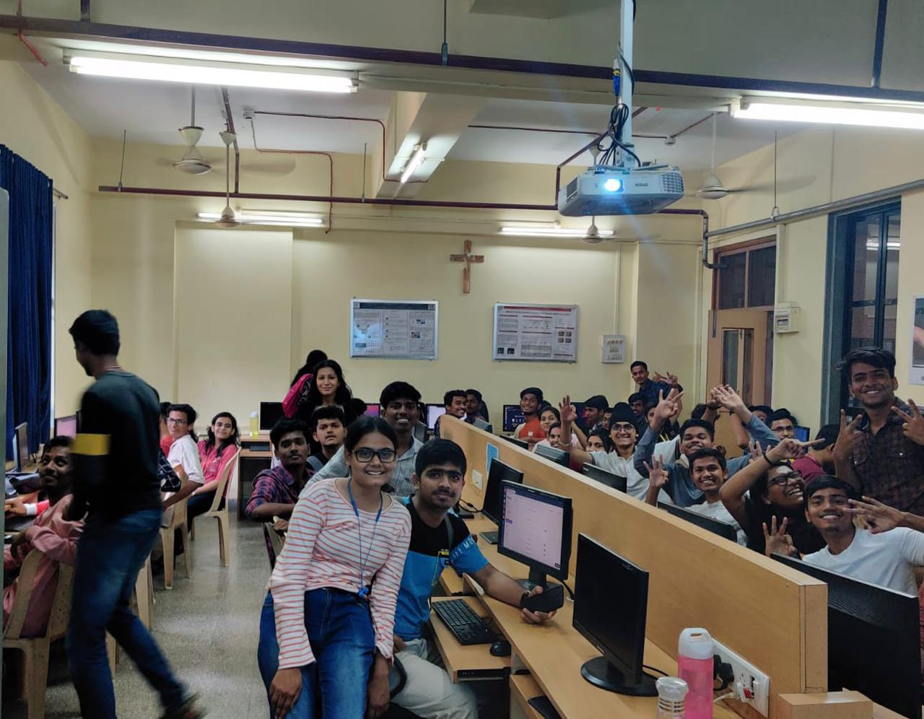

**Activities Jointly Organized by IEEE-DBIT and IETE-DBIT-ISF**

* Bug Busters on 01 April 2021
* Introduction to Micro Bit using TinkerCad 24- 25 March 2021 by Mr. Ashutosh Rane (IEEE), Mr.Sadanand (IETE), Ms. Aparna(IETE), Ms. Purva (IETE) , Ms. Prajna (IEEE)

**Congratulations!!**

IETE-DBIT-ISF was one of the ISFs that were selected as the BEST ISFs by the IETE Mumbai Centre for the academic year 2021-22. The IETE DBIT Student Chapter Coordinator Mrs. Poonam Chakraborty received the award during the IETE Oscillations Valedictory Ceremony on 16 April 2022.

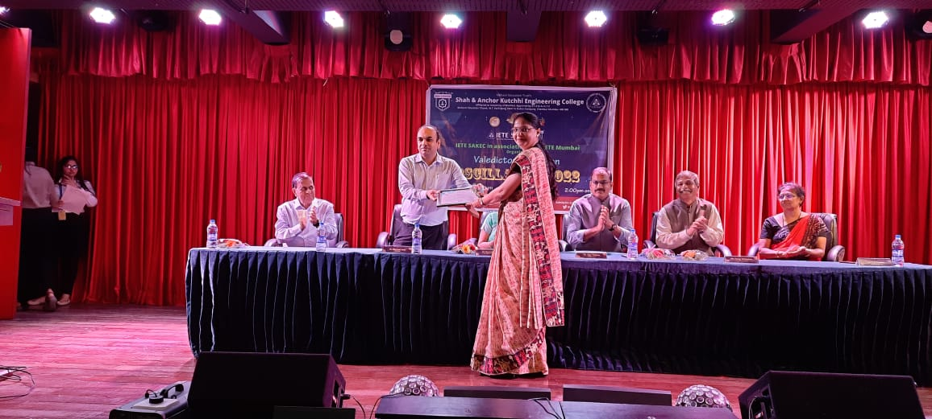

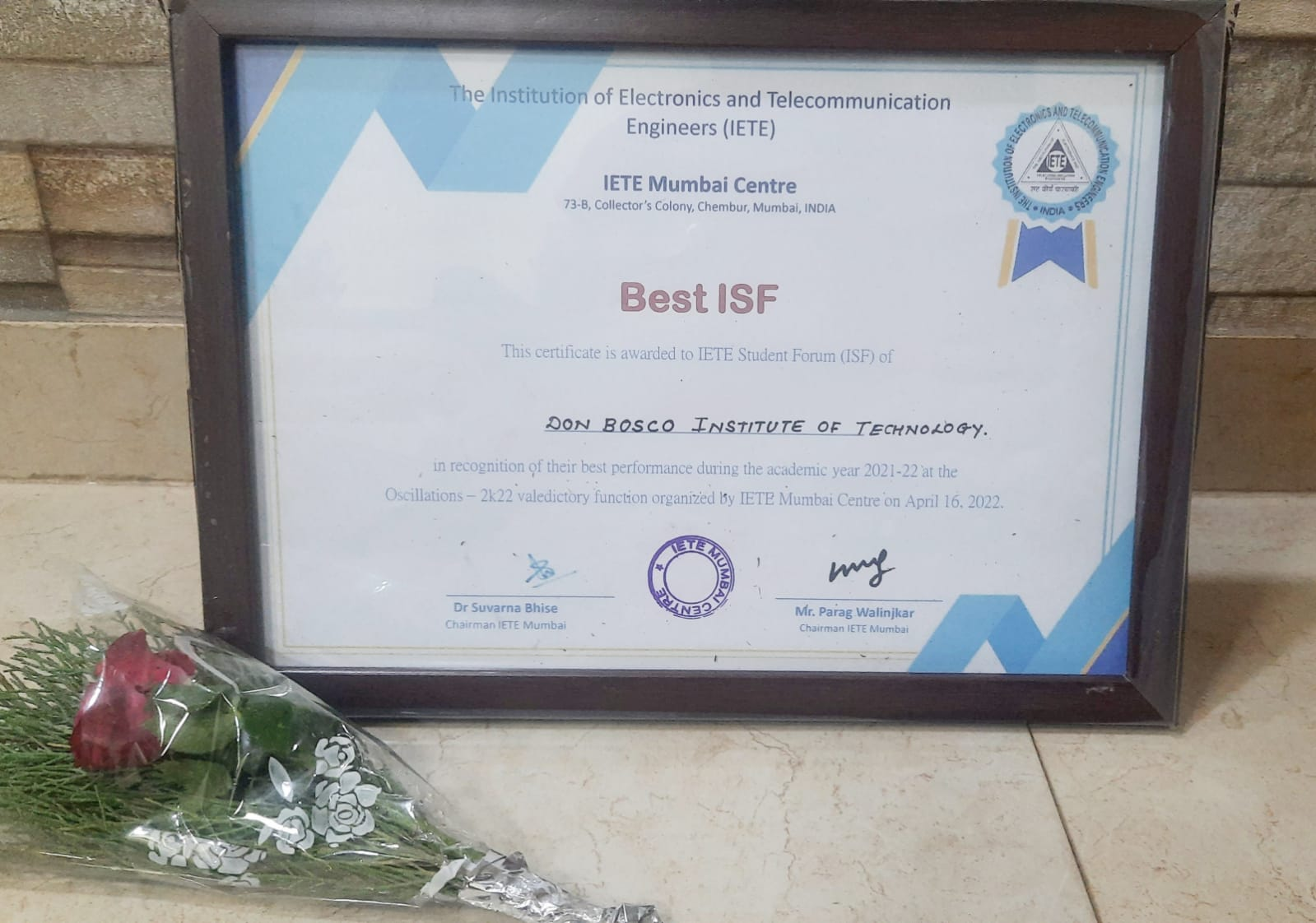

**Symposium Attended by Faculty Members**

* Mrs. Pratibha Dumane and Mrs. Gejo George attended Online National Industry Institute Symposium on “Enhancing Employability of Engineering Graduates through Implementation of NEP-2020” organized by the Training & Placement Cell of Thakur College of Engineering and Technology, Mumbai on 10 July 2021.

**Faculty Development Programs (FDPs)**

1. Ms. Madhavi S. Pednekar attended the ISTE approved one week online FDP on “Sensor Technology” during 5-10 July 2021 organized by the Department of Electronics and Telecommunication Engineering, Xavier Institute of Engineering, Mahim, Mumbai.
2. Mrs. Gejo George attended a one week FDP on “Incorporating Universal Human Values in Education (an AICTE initiative)” from 26-30 July 2021.
3. Mrs. Pratibha Dumane attended a six days online FDP on “AI & Data Science - The Future of Tomorrow” organized by Dept. of Computer Engineering, Rajiv Gandhi Institute of Technology, Mumbai from 29-31 July 2021 and 5-7 August 2021.
4. Mrs. Pratibha Dumane attended a five day FDP on “Incorporating Universal Human Values in Education”' organized by All India Council for Technical Education (AICTE) from 16-20 August 2021.
5. The department faculty participated in a session conducted by Dr. S. Krishnamoorthy on “Integrated Project Based Learning” on 02 December 2021.
6. The department faculty members attended a one day FDP on “Working Harmoniously for Institution Building” conducted by Rev. Fr. Godfrey D’Sa, Founder-Director, Prafulta, Centre for Psychological Wellness on 26 March 2022 at DBIT.

**Short Term Training Programmes (STTPs)/ Workshops Attended by Faculty Members**

1. Mrs. Namita Agarwal attended an AICTE sponsored one week online STTP on “Natural Language Processing with Google AI and Dialog Flow and its Application” organized by Usha Mittal Institute of Technology, Mumbai, from 21-26 June 2021.
2. Mrs. Aparna Telgote and Mrs. Poonam Chakraborty attended AICTE sponsored one week online STTP on “Telecommunication Networks - Phase II” organized by Vidyalankar Institute of Technology, Mumbai, from 5-10 July 2021.
3. Mrs. Namita Agarwal participated in a workshop on “Introduction to Virtual Labs” organized by ICFAI University, Jaipur in collaboration with IIT Delhi on 30 July 2021.
4. Mrs. Pratibha Dumane attended a two-day online workshop on “Write Research Article using LaTeX” organized by Aditya College of Engineering, Surampalem, Andhra Pradesh on 27-28 December 2021.
5. Mrs. Pratibha Dumane attended a 5-day workshop on “Creating Dynamic Dashboards” organized by Skill Nation from 1-6 March 2022.

**Webinars Attended by Faculty Members**

1. Mrs. Pratibha Dumane attended a webinar on “Cyber Forensics: Investigation Techniques and Tools for Contemporary Cyber Crimes” organized by Bharati Vidyapeeth's Institute of Computer Applications and Management, New Delhi on 10 July 2021.
2. Mrs. Pratibha Dumane attended a webinar on “Essential Mathematics for Machine Learning” organized by Dept. of Mathematics in association with IQAC, Guru Nanak College, Chennai on 03 August 2021.
3. Mrs. Pratibha Dumane attended a webinar on “Strategic Approach for Research and Innovation” organised by AICTE on 26 August 2021.
4. Mrs. Namita Agarwal attended a webinar on “AI in Healthcare” organized by Society Of Indian Radiographers and Technologists, Coimbatore, Tamil Nadu on 09 October 2021.
5. Mrs. Pratibha Dumane participated in the online training/webinar on “IEEE Xplore” organised by Don Bosco Institute of Technology on 13 November 2021.
6. Mrs. Pratibha Dumane attended a webinar on “ANN Basics, Deep Learning & its Applications” organized by Bharati Vidyapeeth’s Institute of Computer Applications and Management, New Delhi on 20 November 2021.
7. Mrs. Namita Agarwal attended a webinar on “Industry 4.0 - Trends and Challenges” organized by Bharati Vidyapeeth’s Institute of Computer Applications and Management, New Delhi on 27 November 2021.
8. Mrs. Pratibha Dumane attended a webinar on “Work from Home - New Norm? Opportunities and Challenges” organized by Bharati Vidyapeeth’s Institute of Computer Applications and Management, New Delhi on 18 December 2021.
9. Mrs. Pratibha Dumane attended a webinar on “Machine Learning Algorithms and Behaviour of Data” organized by Bharati Vidyapeeth’s Institute of Computer Applications and Management, New Delhi on 04 March 2022.
10. Mrs. Namita Agarwal attended a webinar on “Artificial Intelligence and Mass Media” organized by Bharati Vidyapeeth’s Institute of Computer Applications and Management, New Delhi on 29 January 2022.
11. Mrs. Namita Agarwal attended a webinar on “Aspirations and Innovation” organized by the Department of IT and NSS, DBIT on 10 March 2022.
12. Mrs. Namita Agarwal attended a webinar on “The Art of Drone Technologies” organized by Bharati Vidyapeeth’s Institute of Computer Applications and Management, New Delhi on 12 March 2022.
13. Mrs. Namita Agarwal attended a webinar on “Cyber Security in the Digital Era” organized by Department of EXTC and IT, DBIT on 24 March 2022.
14. Mrs. Namita Agarwal attended a webinar on “Cyber Forensic Audit: Changing Role of Auditors” organized by Bharati Vidyapeeth’s Institute of Computer Applications and Management, New Delhi on 02 April 2022.
15. Mrs. Namita Agarwal attended an Online National Webinar on “Understanding PCOS” organized by IEEE WiE Bombay Section in collaboration with Association of Social Service Superintendents, Maharashtra on 09 April 2022.

**INNOVEX 2022**

The sixth edition of the Final Year Annual Project Exhibition ‘INNOVEX 2022’ was presented by the​ final year students of DBIT on 13 April 2022. Mr. Sahil Gandhi, Manager - Central Depository Services (India) Limited (Batch 2005 DBIT Alumnus) was the Chief Guest for the event.

The Department of EXTC exhibited 14 projects of the 19 projects which were shortlisted by the department after an internal review. The projects were under the following four categories: 1) Product Development 2) Emerging Technologies 3) Research 4) Sustainability.

The judges for INNOVEX 2022 for the Department of EXTC were Mr. Jovin Miranda, Senior Applications Engineer at Synopsys Inc., Santa Clara, California, USA and Dr. Dhananjay Patel, Associate Professor at Vidyalankar Institute of Technology, Mumbai, India.

| Mr. Sahil Gandhi, Chief Guest | Inauguration |
| --- | --- |
|  |  |
| Students Demonstrating their Projects | |

| **INNOVEX 2022 Winners** | | | |
| --- | --- | --- | --- |
| **Position** | **Project Title** | **Name of Students** | **Project Guide** |
| First Prize and Winner of Prof. D. Sundararajan Award | Low Cost Portable Digital Storage Oscilloscope | Joshua Chettiar  Nilesh Dharap  Atul Kumar  Ankit Kumar | Mr. Yogesh Gholap |
| Second Prize | Design & Analysis of a Compact Metasurface Filter    &    Design & Analysis of a Compact Metasurface Based Phase-Shifter | Hitesh Badgujar  Aman Khan    &  Sadanand Chauhan  Solomon Stephen | Dr. Ashwini Kotrashetti        Ms. Freda Carvalho |
| Third Prize | Smart Voting Machine using FPGA | Callistus Pani George  Ritik Kumar  Vivek Bangera  James Kundukulangara | Dr. Sudhakar Mande |